Solution Blueprint: Securing AI Agents with Okta & AWS AgentCore

1. Executive Summary
The following documentation provides a Solution Blueprint for securing AI agents, detailing how the integrated strengths of Okta for AI Agents and AWS AgentCore address various security challenges. By implementing this architectural approach, organizations can eliminate identity management overhead for developers, replacing disjointed security with a cohesive, declarative framework that enables teams to focus on advancing agent features.
We will discuss
- Strategic Roles:
  - Okta acts as the central identity hub, establishing trust by enforcing governance to ensure agents operate strictly on behalf of verified users.
  - AWS AgentCore functions as the execution and orchestration layer, securing the agent's runtime environment, tool interactions, and gateway communications across cloud infrastructure.
- Use cases illustrate how the platforms combine their features to handle scenarios such as restricting agent access to authenticated users, delegating user identity for APs, and MCP resources.

The integration of Okta and AgentCore optimizes secure access to resources. By adopting this architectural model, organizations can remove identity management tasks for agent developers. Fragmented security is replaced with a unified, declarative framework that is easy to maintain, enabling development teams to prioritize agent features.

2. Technical Architecture
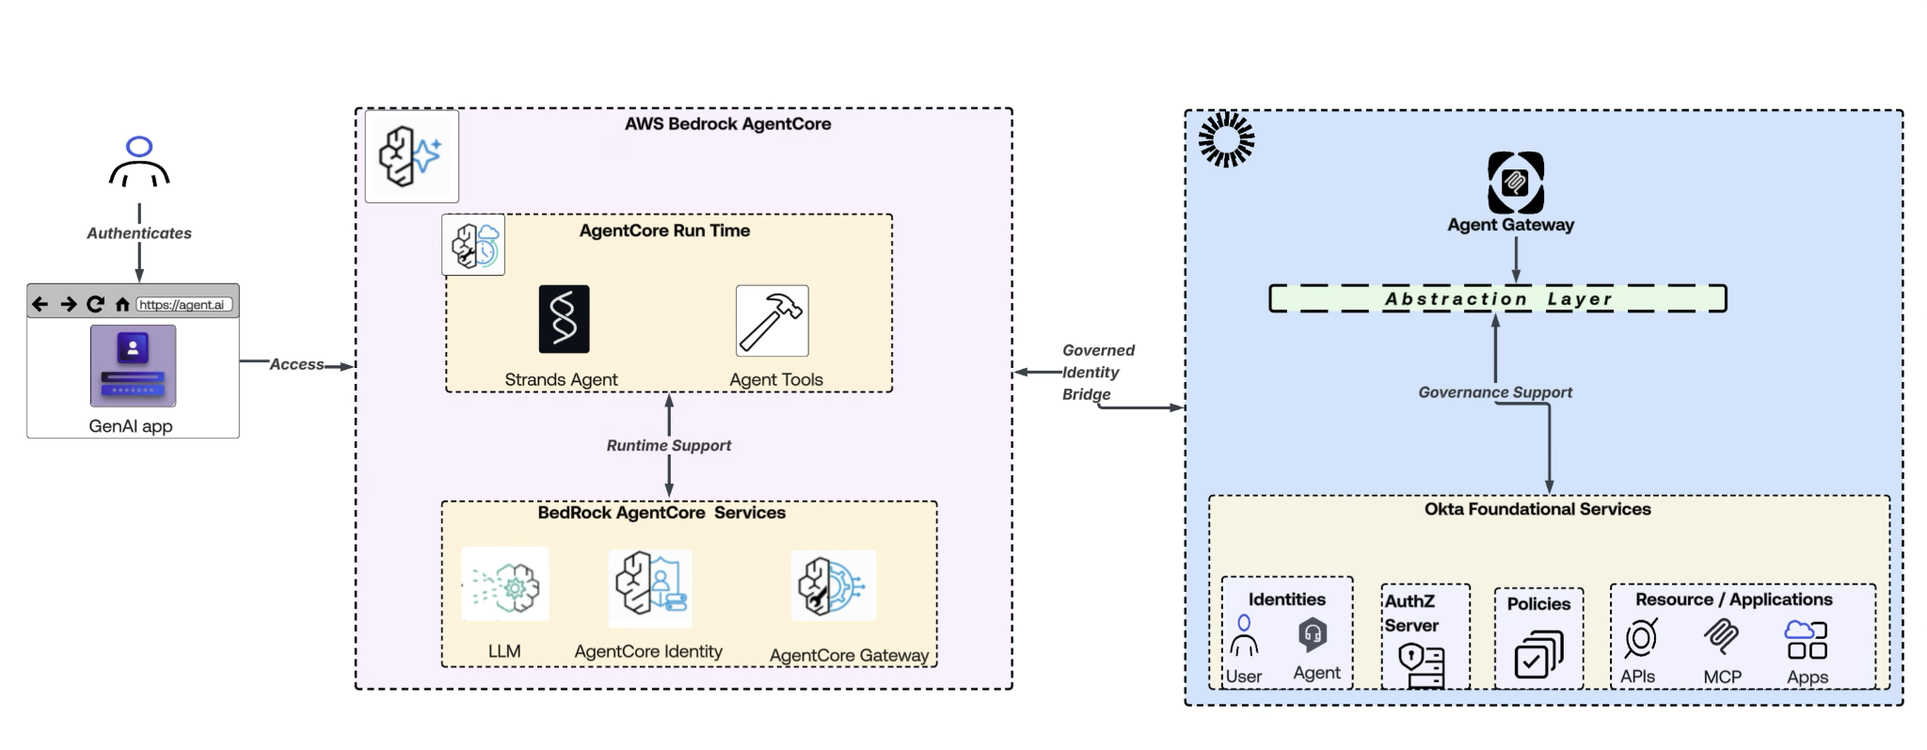
High-Level Architecture flow

3. Technical Architecture

The following glossary defines the core capabilities utilized across the combined identity and runtime architecture:
- Identity-based controls enforce existing enterprise IDP policies, user groups, and conditional access rules directly to agent actions.
- Cross App Access (XAA): protocol to establish standard-based cryptographic trust for all agent-to-app and app-to-app communications.Provides a repository to catalog and track authorized AI agents, enabling their control and management.
- Kill Switch: Revoke access tokens or pause agent actions via continuous evaluation networks the moment rogue behavior is detected.
- HITL (Human in the Loop): Pauses agent execution during sensitive or high-risk tasks and securely routes an approval request to a human's registered device before resuming.
- Agent/User Policy definitions: Dictate granular access rules to evaluate both the agent's structural permissions and the human's identity context.
- On Behalf of a User flow: Restricts an AI agent's blast radius by ensuring it performs actions strictly within the authenticated boundaries and permissions of the specific user.
- Token Exchange: Implements OAuth 2.0 patterns (such as RFC 8693) to allow an agent to securely swap its primary identity token for a scoped, short-lived access token targeted at a specific downstream application.
- Agent Gateway: Serves as the secure architectural point of entry that routes, intercepts, and enforces incoming and outgoing token validation for all tool integrations.
- Credential Provider: Okta and AgentCore empower enterprises to dissolve siloed security models. Okta is an identity orchestrator that oversees the full lifecycle of agent credentials across the corporate landscape, and AgentCore operates as the robust execution environment, leveraging an integrated Token Vault to safeguard sensitive credentials during local task orchestration.
- Unified Telemetry and Audit Trails: Security logging about identity threat detection, configuration drift, and authentication attempts, while AgentCore captures session records, tool execution logs, and runtime telemetry via Amazon CloudWatch.

4 Collaborative Approach & Use Cases

Agentic flows involve numerous variations. Each distinct variation necessitates a unique combination of solutions, tools, and features within both Okta and AgentCore to effectively address the use cases. Therefore, the main focus when comparing Okta and AgentCore should not be on competition, but rather on how their combined capabilities can solve these challenges.
Joint Okta & AgentCore Use Cases (Where They Interlock)

Use Case 1: Zero-Trust Inbound Agent Activation
- The Scenario: Restricting the environment launch of high-privilege AI workloads to authenticated, risk-verified employees only.
- Strategic Position:
  - Okta's Role: Evaluates corporate credentials, network egress flags, and real-time device health to issue a secure user access token.
  - AgentCore's Role: Intercepts the request at the entry gateway, validates Okta’s cryptographic token signature, and spins up an isolated runtime session thread.
- The Bottom Line: Okta secures the enterprise perimeter; AgentCore leverages that validation to safely spin up the underlying AI compute space.

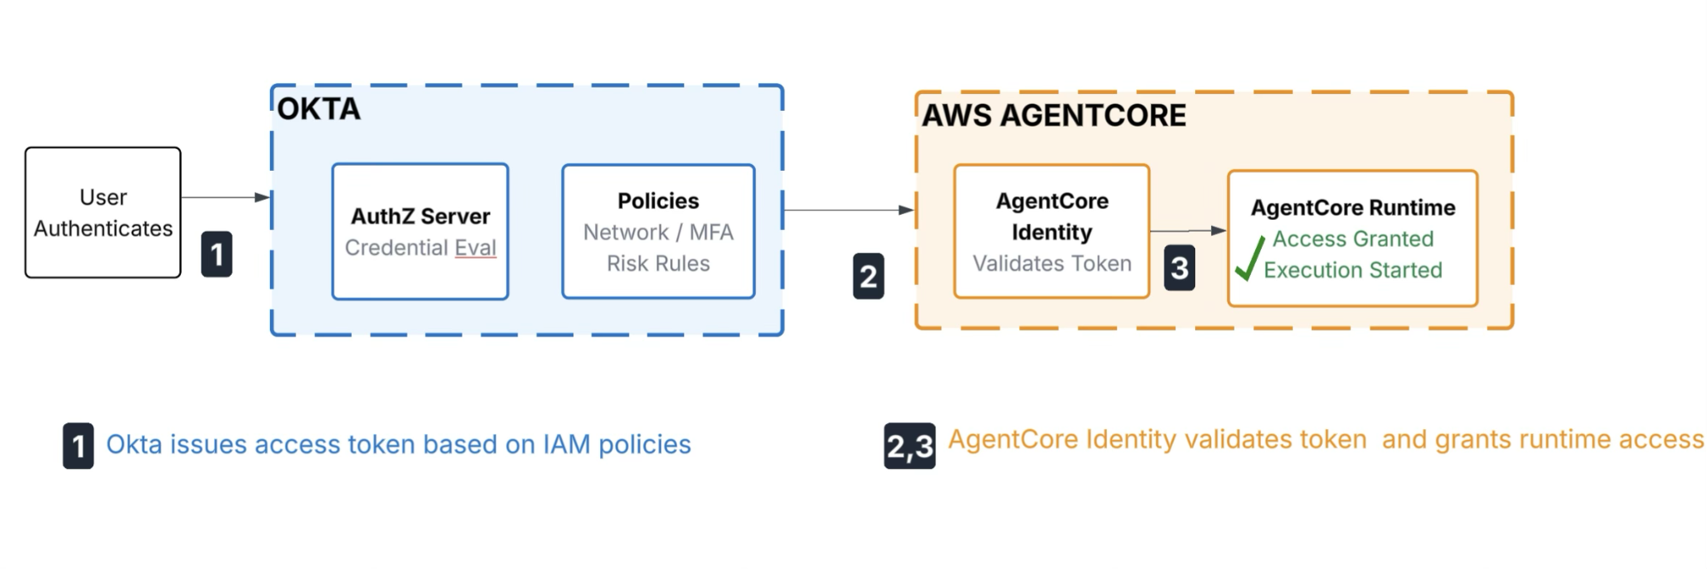

Use Case 2: Cross-Boundary Tool Execution (On-Behalf-Of SaaS Fetch)
- The Scenario: An agent needs to securely fetch data from an external API (e.g., Salesforce or Slack) with a specific user’s authority.
- Strategic Position:
  - Okta's Role: Acts as the RFC 8693 token exchange engine to mint a down-scoped, composite delegation token that mathematically links the human and agent identities.
  - AgentCore's Role: Triggers the exchange handshake, caches the resulting token inside its credential provider, and injects it into outbound API headers.
- The Bottom Line: Okta serves as the cryptographic authority to grant cross-boundary access; AgentCore handles real-time credential caching and transport.
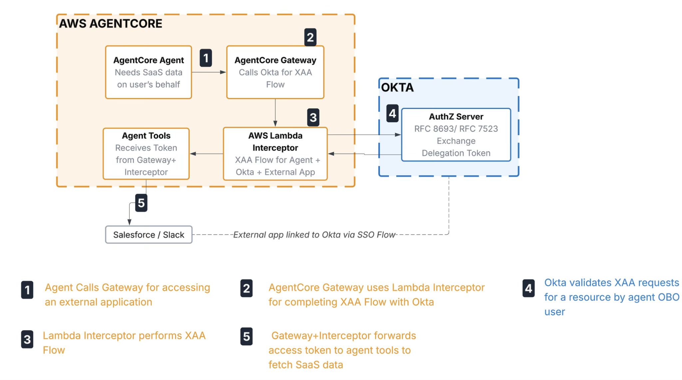
Note: The AgentCore product team recommended the Lambda interceptor pattern as an interim solution during our recent discussions. Future native support for cross-app access within the AWS AgentCore credential provider would eliminate the need for this pattern. Currently, the partnership team is actively collaborating with the AgentCore team to integrate native cross-app access support.

Use Case 3: Secure AWS Resource Invocation
- The Scenario: An agent must trigger AWS resources (e.g., Lambda functions) to execute backend logic.
- Strategic Position:
  - Okta's Role: Provides the initial system configuration and essential identity tokens to verify the user is authorized to perform the task.
  - AgentCore's Role: Configures the full environment, maps the agent's intent to specific AWS actions, and manages secure execution.
- The Bottom Line: Okta provides verified identity and configuration; AgentCore orchestrates the secure execution of AWS resource calls.
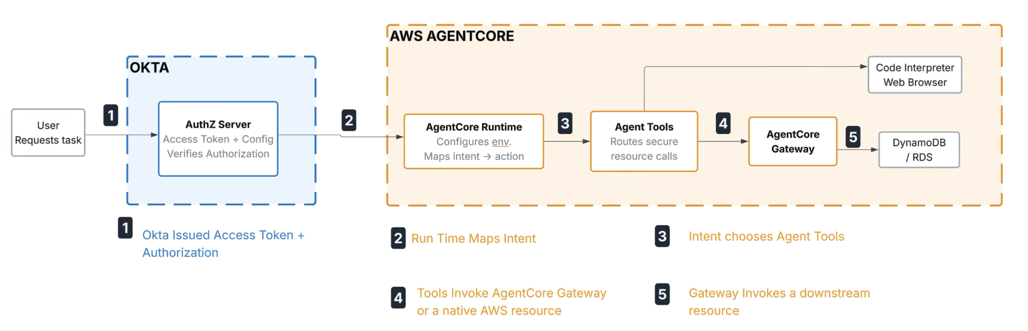

Use Case 4: Agent Kill Switch
- The Scenario: Instantly freezing a live AI reasoning loop the exact second a security team flags an active user session as compromised.
- Strategic Position:
  - Okta's Role: Detects identity-level risks and fires a continuous access event signal out across the identity ecosystem, including agent runtime.
  - AgentCore's Role: Intercepts Okta's revocation signal mid-flight and immediately kills the running agent session.
- The Bottom Line: Okta serves as the central radar that detects the identity compromise; AgentCore acts as the emergency brake that stops the AI compute loop before damage occurs.
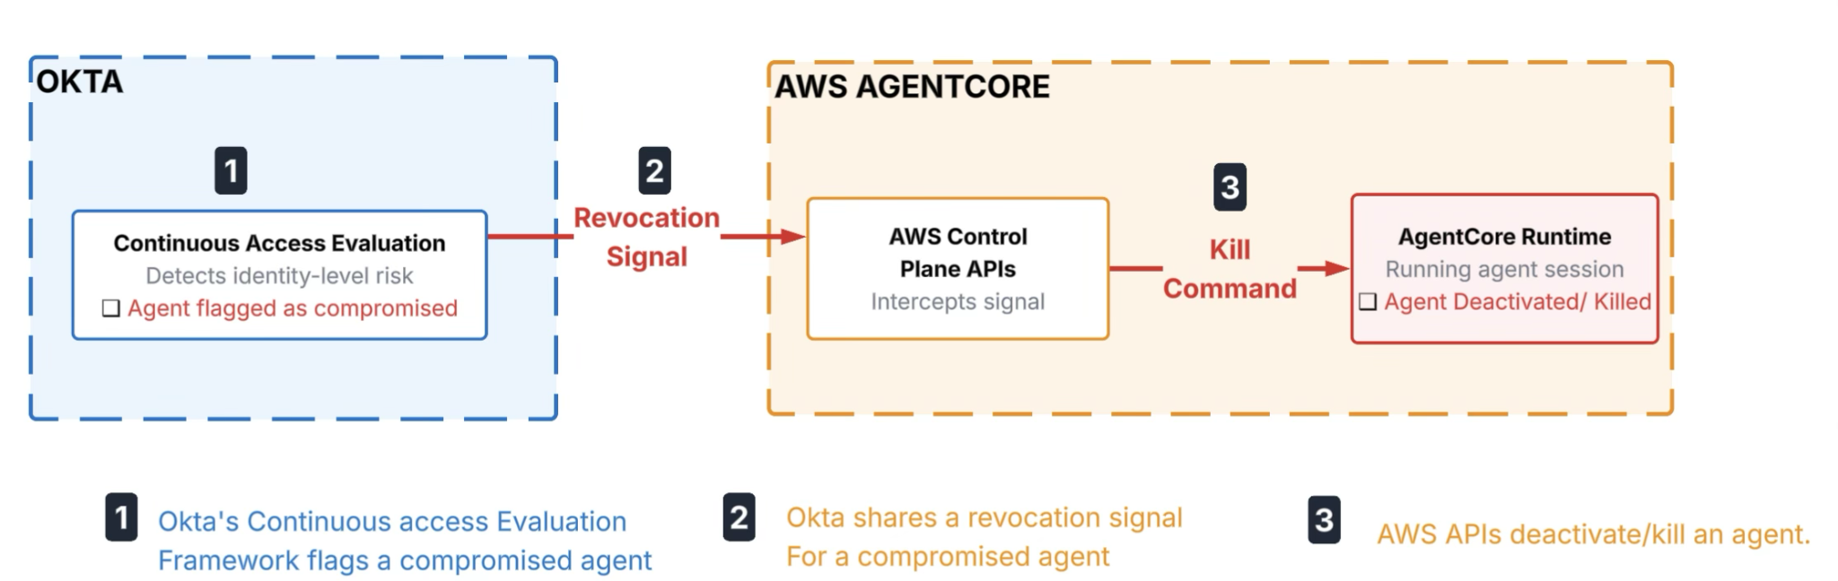

Use Case 5: Fine-Grained Authorization
- The Scenario: Designing a secure system that handles both corporate relationship rules and live tool string guardrails simultaneously.
- Strategic Position:
  - Okta's Role: Governs identity relationships and organizational graphs using Okta (ReBAC) to verify high-level data ownership and tenant boundaries.
  - AgentCore's Role: Monitors real-time payload safety checks at the gateway, parsing natural-language parameters or using Cedar policies to block bad values.
- The Bottom Line: Okta FGA governs the organizational who and what; AgentCore handles the immediate, millisecond-level tool safety checks governing the how.
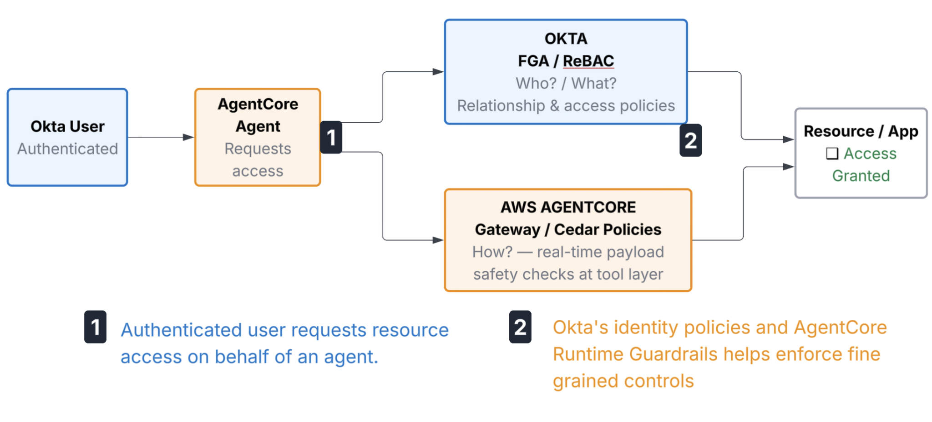

Use Case 6: Human in the loop
- The Scenario: Managing high-stakes operations where an agent triggers sensitive tasks, such as substantial financial transfers or critical database modifications.
- Strategic Position:
  - Okta’s Role: Provides the high-assurance verification layer by issuing step-up authentication challenges to a user device to ensure human sign-off.
  - AgentCore’s Role: Detects a sensitive tool execution attempt and freezes the active reasoning thread, suspending it until external human validation is confirmed.
- The Bottom Line: Use AgentCore to intercept exceptions and pause the runtime; use Okta to facilitate the secure out-of-band identity verification needed to resume work.
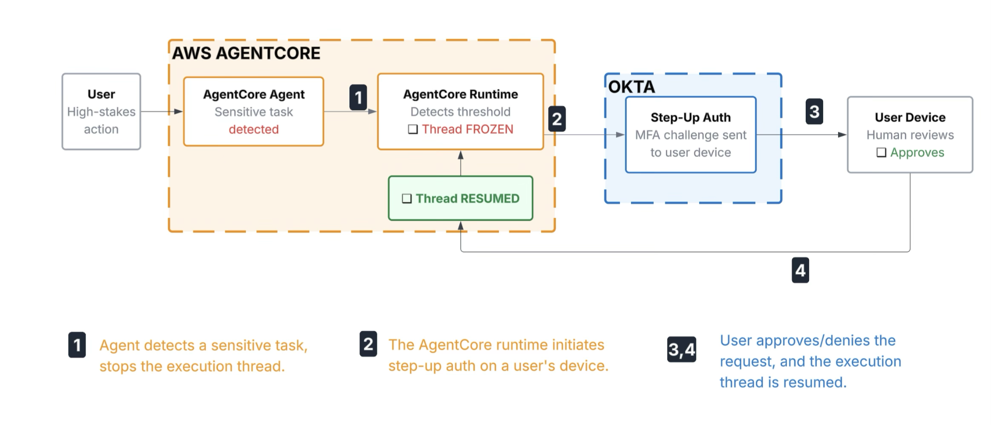

Use Case 7: Token Vault Usage
- The Scenario: Agent is executing a multi-step orchestration thread that takes more than 15-minutes. The token must be rotated without breaking the model inference.
- Strategic Position:
  - Okta’s Role: Acts as the central Token Exchange Server. It evaluates continuous identity risk signals, safely stores long-lived refresh tokens or root app credentials away from the LLM runtime, and mints fresh, down-scoped target tokens on demand.
  - AgentCore’s Role: Acts as the execution layer and Token Exchange Client. Its runtime Token Vault monitors the expiration timeline of the active target token. Before the token expires, AgentCore invokes Okta’s token exchange endpoints mid-flight, retrieves a new short-lived credential, and swaps without interrupting the running state machine.
- The Bottom Line: Okta securely governs master application credential lifecycles at the enterprise perimeter; AgentCore manages token execution continuity inside the agent runtime environment.
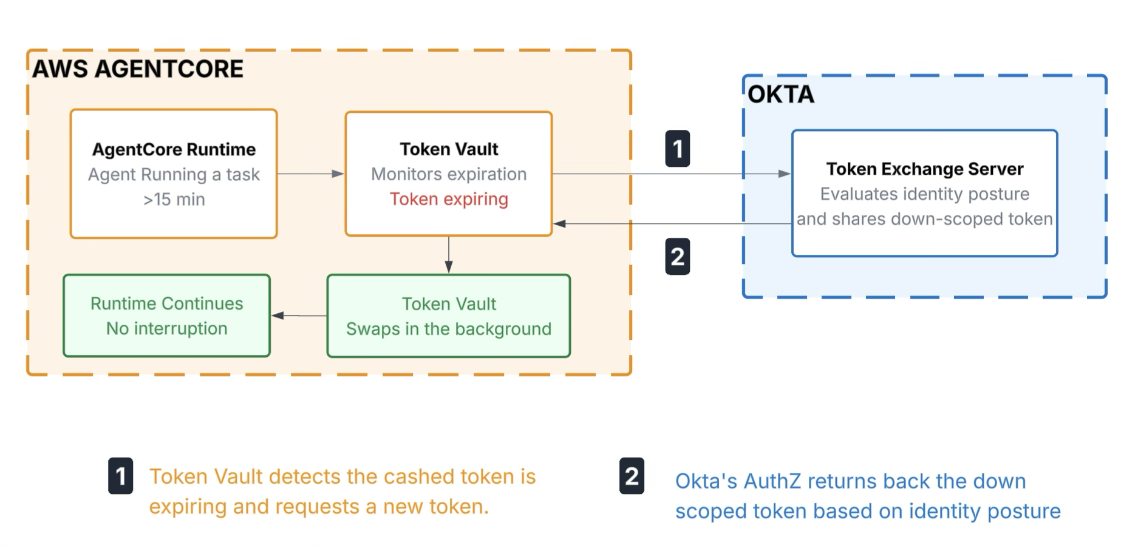

Use Case 8: Registering Agents
- The Scenario: Tracking and managing an AI agent requires both strict regulatory compliance oversight across the enterprise and an optimized, dynamic runtime execution engine.
- Strategic Position:
  - Okta's Role: Registers the agent as a governed entity and binds it to a human supervisor, a cost center, and business attributes, thereby establishing its legal right to operate. It ensures the agent is discoverable by the business without needing visibility into prompt variants or code.
  - AgentCore's Role: Catalogs the actual runtime identity—including specific model versions, prompt templates, vector database indices, and Model Context Protocol (MCP) tool schemas—to ensure the agent compiles and runs efficiently at the code level.
- The Bottom Line: Okta establishes the foundational corporate identity and liability framework for an agent, whereas AgentCore constructs and monitors the cognitive engine. To prevent the emergence of unmanaged "shadow AI" and to guarantee that every active agent is strictly accounted for within the organization, it is essential to synchronize these two registries. Consequently, the ongoing management and maintenance of both identity types are vital.

5. Differentiator

Think of Okta for AI Agents as the enterprise’s identity hub. It’s the root of trust that handles the heavy lifting for governance, manages the lifecycles of human and agent identities, and ensures cryptographic security is consistent across your entire app catalog.

On the other hand, AWS Bedrock AgentCore is where the action happens. It functions as the execution layer, running the local orchestration loops, routing tasks between models and tools, and providing the gateway and hosting environment—whether you’re using the CLI, SDK, or Step Functions.

Identity-Based Controls & IDP Policies
- The Nuance: Both talk about "enforcing identity policies," but they evaluate different stages of the execution.
- Okta: Evaluates the requesting user (e.g., checking device compliance, network controls, password policies, MFA policies, etc.).
- AgentCore: Acts as a Relying Party (RP), consumes the signed JWT issued by Okta to authorize the initial boot-up and session for agent execution.
- So What?: Use Okta to establish the outer perimeter of trust and contextual risk. Use AgentCore to read that resulting identity context and instantiate the agent execution.

Agent Registry
- The Nuance: An AI agent needs a digital worker that requires strict regulatory oversight across the identity ecosystem and dynamic runtime engine.
- Okta: It registers the agent as a governed agent and binds it to a human supervisor, a cost center, and other attributes. Okta ensures the agent is discoverable by the business, but it has no visibility into the agent’s actual code, prompt variants, or model parameters.
- AgentCore: It catalogs the actual runtime artifacts—the specific model versions, prompt templates, vector database indices, and Model Context Protocol (MCP) tool schemas. AgentCore ensures the agent compiles and runs efficiently at the code level, but it cannot prove who is ultimately responsible for its financial and security liabilities.
- So What?: Both registries interlock. Okta establishes the agent's corporate identities and legal right to operate, while AgentCore builds its actual cognitive engine and toolset; without both registries talking to each other, you either get unauthorized "shadow AI" running untracked in production, or a perfectly governed corporate identity that has no brain or tools to execute tasks.

Cross App Access (XAA)
- The Nuance: XAA is an emerging, Identity-Provider (IdP)- centric protocol designed to eliminate point-to-point OAuth connections and leverage existing trust boundaries.
- Okta: Operates as the central XAA Authorization Server. Admin configures relationships between an agent and a target resource. Okta mints short-lived, cryptographically verifiable tokens specifically bound to that cross-app communication.
- AgentCore: Acts as the execution layer. When an agent framework decides to call an external API, AgentCore initiates the XAA token handshake to retrieve and attach the scoped credential to the outbound payload. Until AWS native code-level integration is available, AWS Lambda tool interceptor and AgentCore Gateway can orchestrate the XAA token handshake. This is a fully supported execution pattern today,
- So What?: Use Okta to define the global cross-app authorization topology and consent states; use AgentCore to manage the XAA execution for cross-app communication.

Kill Switch Architecture
- The Nuance: Neutralizing or deactivating a digital worker is a complex operation involving user identity context, behavioral anomalies, and diverse agent security guardrails. Implementing a true Kill Switch requires effort from both Okta and AgentCore to be truly effective.
- Okta: If an anomaly is detected, Okta blasts a back-channel revocation event that instantly blacklists the agent's access token across all federated SaaS applications.
- AgentCore: Enforces deterministic runtime interception via the AgentCore Gateway. It can immediately kill an active inference loop, freeze a state machine, or drop incoming tool calls mid-thought based on local runtime policies.
- So What?: Use Okta as the Global Kill Switch to instantly strip the agent of its tokens across the enterprise ecosystem. Use AgentCore to pause a rogue loop locally before it causes compute or infrastructure damage.

Human-in-the-Loop (HITL) Verification
- The Nuance: Identifying the need for human validation based on human intent/questions and other configuration limits.
- Okta: Owns the High-Assurance Authentication Mechanism. It issues step-up authentication (MFA, WebAuthn, FIDO2, Okta Verify) to a supervisor's trusted device to ensure that a human cryptographically signed off on the action.
- AgentCore: Analyzes the planned tool execution payload, hits a conditional barrier (e.g., "Transaction > $1,000"), and pauses the runtime thread until an external callback token is received.
- So What?: Use AgentCore to detect the exception and freeze the execution state. Route that exception to Okta to perform secure human identity verification, then pass the signed confirmation back to AgentCore to resume.

Fine-Grained Access Controls
- The Nuance: Enforcing fine-grained control requires combining identity relationship data with runtime payload constraints, tailored entirely to the customer's preferred authorization architecture.
- Okta: Evaluates global identity boundaries. It answers macro-relationship questions: "Does User X have a direct or nested tenant relationship permitting Agent Y to access Database Z?"
- AgentCore: Evaluates real-time payload and tool safety checks at the gateway. Based on customer preference, this runtime tier natively supports either AgentCore policy or AWS Verified Permissions.
- So What?: Use Okta FGA for central identity and relationship ownership boundaries. Use AWS Verified Permissions for runtime tool safety, data redaction, and LLM behavior guardrails.

On Behalf of a User
- The Nuance: Okta issues a token so the agent can act on behalf of a specific user. AgentCore requests a token to query the resource that the user has permission to see.
- Okta: Evaluates the token request and generates a token that safely binds the user context to the active agent.
- AgentCore: Parses this token at runtime. AgentCore passes these identity claims down to downstream resources, where results are filtered strictly by the human user's permissions.
- So What?: Okta provides the OBO token; AgentCore enforces data-tier isolation using those token claims.

Token Exchange (RFC 8693)
- The Nuance: IdP validates claims and signs downscoped tokens. The AI Engine triggers exchanges, caches tokens, and injects them into payloads.
- Okta: Acts as the Authorization Server. It accepts an inbound actor token from AgentCore, validates its authenticity, runs it through corporate token-issuance policies, and returns a down-scoped, ephemeral target token.
- AgentCore: Acts as the Token Exchange Client. Its internal orchestration scripts invoke Okta’s token exchange endpoints mid-flight, converting primary access tokens into app-specific tokens before routing requests to external tools.
- So What?: Position Okta as the Token Exchange Server and AgentCore as the Token Exchange Client will cover many agent flows.

Agent Gateway(s)
- The Nuance: An agent operates across two planes that require different security postures: an internal cloud plane and an external enterprise resource plane. Rather than having a single gateway manage both, the architecture divides responsibilities between a Runtime Gateway and an Outbound Enterprise Proxy.
- Okta: Acts as the boundary of the enterprise environment, covering SaaS apps, local databases, and primary business APIs. It serves as an intelligent egress security proxy. When a cloud-based agent loop accesses the Okta gateway, the gateway manages the transition by translating the workload context into a user-delegated access token.
- AgentCore: AI runtime environment where Okta’s identity plane cannot natively reach. An agent cannot remain an isolated island; it must continuously cross the network boundary to speak directly to external, Okta-protected corporate systems using the exact identity context that Okta controls.
- So What?: Neither gateway can replace the other because neither owns the entire technology estate. Okta secures the external enterprise world the agent needs to affect, while AgentCore secures the internal AI world where the agent actually lives, meaning true zero-trust is achieved only when these two gateways securely handshake across their respective borders.

Audit Trails
- The Nuance: The audit trail for Enterprise Agents is distributed across several systems, and incorporating both the identity management tier and the runtime execution phase is critical.
- Okta System Log: Records authentication tracking, token issuance anomalies, and configuration actions of an agent and tokens across the identity landscape.
- AWS CloudWatch: Captures the exact reasoning trajectory of the agent, prompt token counts, completion payloads, execution latencies, and tool response codes.
- So What?: Funnel both streams into a SIEM. Use Okta to prove who or what authorized the session, and use AgentCore to prove exactly what the agent thought and executed with that authority.

